Advent Unwrapped: The Shape-Shifting Magi
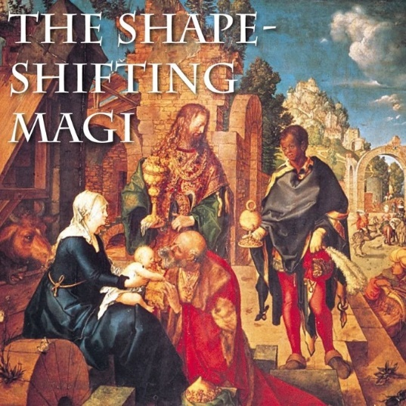
One of the interesting things about mythic stories is that the best ones have very few details. Less is more. Take the Magi who bring gifts to Jesus. We know them as the “three wise men” or “the three kings”, but the gospel account in Matthew doesn’t say either of those things. It simply mentions Magi who bring frankincense, gold, and myrrh. But as the story got told and retold, people wanted to fill in the blanks. How many Magi? Three, since there were three gifts. Wise men? Wise because they sought out Jesus by reading the stars. Men? An assumption. Some medieval paintings show a wise woman. In time, they even gained racial characteristics, and ages too. This picture shows men of three different stages of life, young, middle-aged, and old. Three races, too, representing the three known continents at the time: Asia, Africa, and Europe. They were given names: Melchior, Balthasar, Caspar. Over time, these unnamed, vague astrologers came to represent all of (male) humanity. Totally dropped the ball on gender. That’s patriarchy for you.
This “magi-cal” visit is a reminder that Christianity offered its insights to all the peoples and nations of the world. A lovely idea, but one that also justified a lot of coercive, colonial Christianity over the centuries. Indeed, starting early on, there was a belief that when the Magi met Jesus, any magical powers they possessed simply stopped. Their visit was not just to honour the newborn king, but a capitulation on behalf of pagan cultures. Paganism and its magic had been defeated. (John Milton’s poem “On the morning of Christ’s Nativity” plays on this idea.) So, as the Magi became better defined in the West, they also became tools in an imperial view of Christianity, justifying the conquest of other cultures.
Perhaps at this time, we could benefit from telling new stories about Christians who come with gifts to other faiths and cultures. Not to conquer or convert, but to show respect and listen. Those would be wise visitors, and this time, perhaps not all of them would be remembered as men.

The Fight for Christmas Vacations
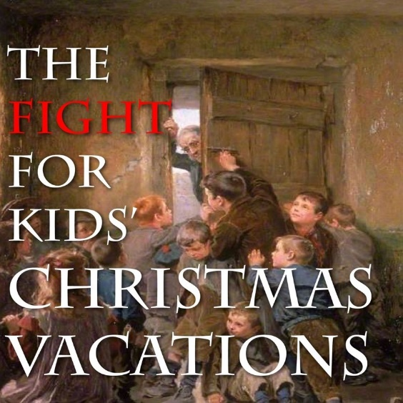
Today we take it for granted that a few days before Christmas, school children will be dismissed from class, and not return until after New Year’s. However, we owe these vacations to the bravery of students in centuries past. In many Protestant countries, Christmas Day was barely observed, and school masters expected children to go to school each day during this period. But kids—being kids—wanted time off. To get it, they engaged in a practice known as “barring-out the schoolmaster”. Students would plan a sit-in. It often began on St Nicholas Day, December 6th, so on the 5th, they would gather enough supplies to last for three days. Food, drink, blankets, even pistols (no joke)—everything they would need to occupy their classroom and keep their teacher locked out. This was a custom in Britain, the U.S., and some parts of Canada (an article in The Toronto Globe in December 1894 describes the practice at a school near Georgian Bay).
The rules were straightforward: use planks and nails to barricade the doors and windows shut. If the teacher couldn’t break in for three days, the school had to grant the students’ demands. Their typical request was for a week’s break from school at Christmas. Sometimes they asked for Christmas presents and treats instead, or along with time off. These demands could be denied—the door would be broken down and a sound thrashing was meted out on the students. Nicer teachers would negotiate a truce before the three days was up. This practice died out in the British Isles in the 18th century as schools adopted charters with vacation times set for Christmas. The practice continued all through the 19th century in parts of North America.
Progress often starts with people who are willing to go on strike, and Christmas vacation for students was no different. To paraphrase the Beastie Boys: You gotta fight for your right to Christmas vacation.

Why do we wrap Christmas presents?

Pretty much everyone who gives a Christmas present wraps it in colourful paper—or a pretty box or gift bag. But why? The historical answer is that back in the 19th century, most people gave each other homemade gifts, which came wrapped in intimacy and affection, but usually without any wrapping paper. When stores wanted in on the Christmas gift business, they were in competition with homemade items. To compete, they started wrapping their products, so they looked more special. In time, everyone was buying wrapping paper for almost all Christmas gifts, even the homemade ones.
The Hallmark Brothers basically invented Christmas wrapping paper in 1917, when they ran out of tissue paper, and sold fancy French patterned paper instead out of desperation. Customers liked it so much Hallmark started making their own wrapping paper. Today, stores sell us not only the present, but the wrapping too. Not a bad hustle!
But why does a gift need to be wrapped at all? We can sense that a certain magical quality is lost with an unwrapped gift. The addition of a thin layer of colourful paper transforms a product into a gift. There is a temporary sense of possibility, where one thing could be many (is it a watch, a ring, a Fitbit?). Wrapping paper lends a gift of cosmic possibility, a connection to the rest of the universe, literally and in the imagination. All those possibilities last until the moment we rip open the paper, and the gift collapses, to be revealed as only what it is.
That sense of possibility seems entirely in keeping with Christmas, when we are invited to believe that almost anything is possible. It’s not hard to imagine why we have opted for that sense of wonder and possibility, even for products we could have purchased on ourselves. Wrapping paper is the material expression of the Christmas spirit.

—Rev. Stephen Milton came to Lawrence Park Community Church in Toronto in 2019, after decades of work as a documentary filmmaker. His passion is creating new ways to explore spirituality, appealing to people who aren’t interested in regular Sunday morning church services.

