# Advent as a Season of Invitation

## Why Advent?

The Advent-Christmas story is a key moment of invitation in the gospels of Luke and Matthew, where people are invited to “come and see” the new thing God is doing. For many, December is a natural time to be thinking about spirituality with the themes of gratitude and hope floating in the air. As church leaders we also know that Christmas Eve is a time when our sometimes-hesitant congregations are more accustomed to inviting others to church activities, even if it’s just their family. For all of these reasons, Advent is a wonderful season to work on the invitation-culture of your church.

DISCLAIMER: This guide is not meant to generate **more activities** but to uplift and support the wonderful ministry you are **already doing**. We invite you to think about choosing to focus on a few activities your congregation can do well and then coaching your regulars to invite their neighbours into those moments.

DISCLAIMER THE SECOND: In many instances this will be the first time your church has been intentional about their invitation-culture in a long time, so be sure to **make space for grace**. Make space for the gracious work of the Holy Spirit in your own hearts as you engage with your neighbours in new ways, lean into the discomfort that comes from learning new things, and live into the call we find in a New Creed to proclaim Jesus; make space for the gracious work of the Holy Spirit in the hearts of those you invite, remembering that it’s ultimately God, not your hard work, who gives growth (1 Corinthians 3:7); and make space for the gracious work of the Holy Spirit to bring you into a deeper sense of oneness with your neighbours as you are transformed together by God.

## Make a plan

We want to curate and highlight different moments of invitation throughout the Advent season for our congregations. For this to work well, it is important for leadership to communicate with church regulars that together you are being intentional about creating opportunities for them to **personally** invite their friends and neighbours to church. Your plan doesn’t need to be complex, but it should be clear about **who you hope to invite**, **who will do the inviting**, **how you will welcome newcomers** (whether it’s for the first time or the first-time-in-a-long-time), and then **next steps**. We want to offer straightforward steps for congregations, inviting them to think about their social circles and who might be blessed by coming to a carolling event or attending a communal Christmas dinner. We want them to be intentional about inviting a friend or neighbour, and we also want them to feel like it’s natural rather than forced.

As your leadership team puts your plan together, think about who you hope to invite and **what you hope they will experience** in your midst:

* A calm space for reflection, lament, and gratitude during the holiday chaos
* A place to go where you will be welcomed and included during a season of “activities” where many experience loneliness
* An inspiring story about how God has, through Jesus, and continues, through the church, to express their hope, peace, joy and love in the world

Make sure your invitations are active as well as passive. In fact, the passive invitations (social media posts, flyers, newspaper ads) are most effective when they help us to make better personal invitations. Ask every household (single adults, couples, or families) to invite and accompany someone to your invitation-moment.

## How do I actually get my regulars to invite their friends and neighbors?

### Tip 1: Communicate clearly to your congregants the intended audience of specific activities/events.

When sharing about upcoming events let your folks know who you hope they will invite. “We want to reach out to families with young children and invite them to our upcoming Messy Church Christmas event.”

### Tip 2: Create an invitation card.

An [invitation card](https://united-church.ca/sites/default/files/2024-11/au-invitation-card.pdf) offers congregants something tangible to give out when extending an invite. Postcard-sized invitations can be stuck up on fridges with all the info for an upcoming event so you’re not worried about details getting missed. Be sure to emphasize that these are meant to be passed out personally, not dropped in mailboxes!

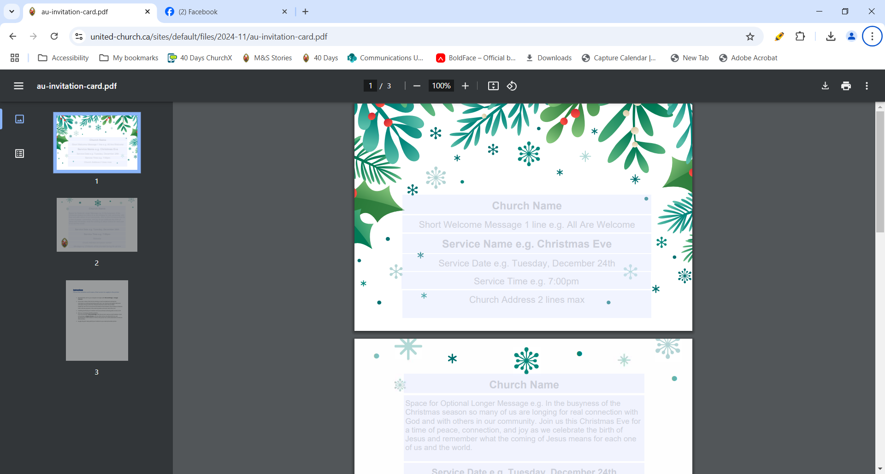

[Advent Invitation Card](https://united-church.ca/sites/default/files/2024-11/au-invitation-card.pdf)

### Tip 3: Emphasize how invitation is a gift to God and your community during your Sunday offering.

During your offering time, connect how invitation is a response to God at work in our lives.

Example:

Now is the time that we ask you to consider how you might be called by the Spirit to offer yourself in generosity at _____________ United Church and in the city that we’re called to serve. Here at ____________, that usually includes giving financially to sow generosity in our hearts and help fulfill our shared mission, sharing our spiritual gifts in a way that brings us life and serves as a blessing to others, and inviting others who aren’t yet part of this community so that we might be transformed together by the story of Jesus and the love and grace of God.

### Tip 4: Pray for those you are inviting.

Encourage church regulars to pray for those they are planning to invite. When we pray for people, we are both calling on God to be deeply present in their lives and deepening the care we have for that person in our heart. We can also ask the Holy Spirit to be with us as we offer invitations. If providing some language for prayer would be helpful to your congregation, here is an example you might use:

God, I thank you for (*name*), especially for (*specific example of gratitude*). I know that you love (*name*), and I ask that you would help them to feel that love deeply today, especially as it pertains to (*specific situation*). God, as I prepare to invite (*name*) to (*specific event*), I also ask that you give me the confidence and humility I need to share my faith well and the wisdom to know when it is appropriate to share.

### Tip 5: Roleplay invitation.

Create a short skit to share during a worship service where a church regular invites an acquaintance to an event. You can also role model how to receive a “yes” *and* a “no” graciously.

We have provided an example video you can share, which is available on The United Church of Canada’s YouTube channel.

[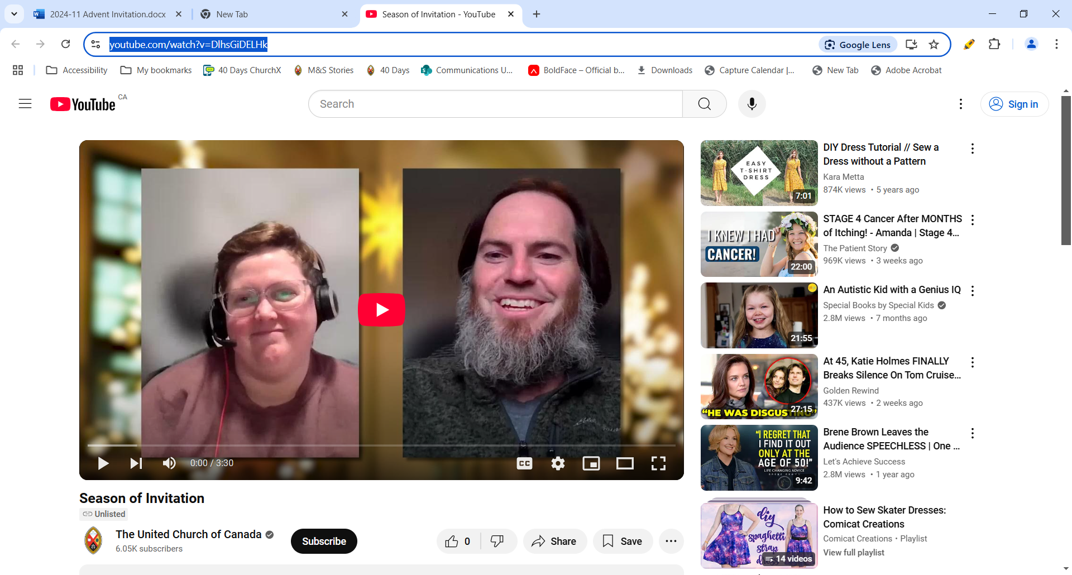](https://www.youtube.com/watch?v=DlhsGiDELHk)

[Season of Invitation video](https://www.youtube.com/watch?v=DlhsGiDELHk)

### Tip 6: Practise sharing your stories.

During Advent create a 2- to 3-minute moment in the service for congregants to practise sharing how Christ has impacted their lives, perhaps connected to the Advent themes of Hope, Peace, Joy, and Love. The more we practise talking about our faith with other church regulars, the easier it is in the moment with a friend or neighbour.

Example for Advent 1, Hope Sunday: Christ is our source of hope. Share with a neighbour beside you how Christ has been a source of hope in your life in the last year.

### Tip 7: Pair the uncomfortable with the familiar.

One way to get over the awkwardness of inviting someone to church is to focus on what might be familiar to them. Christmas Eve can be an especially helpful time to do this because it is one of the few times that the worship service itself feels more familiar to many.

“We’d love to invite you to join our family for Christmas Eve. This year our church is doing free family portraits before the service, since we know lots of folks enjoy dressing up for the occasion!”

“I know your kids loved visiting the farm this summer. After our Family Christmas Eve service this year there will be an opportunity to pet the animals from the live Nativity. Would you like to join us?”

### Tip 8: Pair the invitation to church with an invitation to deeper relationship.

When you invite someone to church, consider inviting them to dinner at your home beforehand or to grab hot chocolate on the way home.

“Beth and I are going to the late Christmas Eve service and wondered if you two would be interested in coming over for snacks and carols at our place afterwards?”

“Friends and I are going out for dinner before the pop-up Christmas Choir at my church. Both the restaurant and the church are fully wheelchair accessible. I know you love to sing—want to come with us?”

## Follow up

The time when the most barriers are connected with your church is before someone comes for the first time, but those barriers usually don’t all disappear after someone has their first experience with church. We need to be intentional about following up with first-timers. If someone has come with one of your church regulars to an activity, knowing what the next step will be is important. Sometimes the next step happens naturally. If someone attends an Advent activity, for example, the person who invited them might then ask them to come to the Christmas Eve service. Encourage these natural next steps!

It’s also helpful to have a plan that your church regulars know about for what the typical next step is for someone who is new. If someone came to your church and asked outright, “What does it mean for me to follow in the way of Jesus in this church?” what next step would you recommend? People don’t often ask the question quite that specifically, but it’s often a question that, if answered, helps them to feel more confident about their place in your community of faith.

It might be introducing them to a leader. It might be a regular newcomers’ lunch. It might be an introductory discipleship program designed for people who are new to the church. Whatever that next step is, it should be clear, specific, and well-known by your regulars, and it should welcome the new person into relationship with more than just the person who initially invited them.

***

If you want to learn more about how your community of faith can better welcome newcomers of all ages, contact your regional Growth Animator at [Growth@united-church.ca](mailto:Growth@united-church.ca).