# **Advent Prayers of the World**

In the season of Advent, we wait, preparing our hearts for the hope, peace, joy, and, love that Christ brings to a world often marred by division and suffering. Advent calls us to anticipate God’s transformative presence in our lives and communities as we journey toward Christ. This season, we are invited to focus on global partnerships that reveal the spirit of Advent alive in the efforts for justice, peace, and dignity for all people. More deeply, we are invited into mutual transformation through The United Church of Canada’s mutual radical accompaniment with these four global partners.

Through prayer, reflection, and solidarity with global partners, we recognize Christ’s presence among us, sharing in both the celebrations and the struggles of communities around the world. May we meet their calls and advocate to our governments and structures to bring about a more just world.

This Advent, you are invited each week to pray with and lift up the work of global partners who faithfully embody these Advent themes in their unique contexts, working toward justice, reconciliation, and hope in places near and far.

May these Advent moments draw us closer to the heart of God, moving us to respond with compassion and solidarity, supporting efforts to bring about a world where all may flourish.

## Advent 1: Hope

### Global Partner: The Evangelical Seminary of Theology (SET)

[The SET](https://www.globalministries.org/partner/lac_partners_evangelical_seminary_of/) is a theological education institution. Students are formed biblically, theologically, and pastorally to carry out different ministries and responsibilities in their churches and faith communities, from pastoral work to diaconal, liturgical, and chaplaincy, among others. The SET also serves the surrounding community by sharing purified water, garden-harvested food, and helping people in poverty.

#### We celebrate the following:

On October 1, 2024, we celebrated 78 years of uninterrupted educational work and evangelical witness. We deeply thank God for the opportunity to serve the churches and our people for so many years. We thank God for the lives of those who have preceded us in this important work, and for the call that leads us to continue it, especially in these difficult and challenging circumstances.

#### We pray and long for the following:

Although we feel called by God to carry out our educational and community service work, especially in the difficult circumstances we are experiencing:

We hope and pray that the socio-economic situation of our country will improve considerably.   
We hope and pray that the obstacles to this improvement can be overcome or removed.   
We hope and pray that youth will find a place for the hope of a better present and better future in our homeland.   
We hope and pray that God will give us the intellectual and spiritual skills to carry out the mission of this academic institution and the church in Cuba.

#### What can we in Canada do to advocate in solidarity with SET?

It is crucial that Cuba be removed from the US State Department list of states sponsoring terrorism. This condition exacerbates the effects of the economic, commercial and, above all, financial embargo imposed by the United States against Cuba. Contact your MPs and apply international pressure through our close relations with the government of the United States.

## Advent 2: Peace

### Global Partner: The Middle East Council of Churches (MECC)

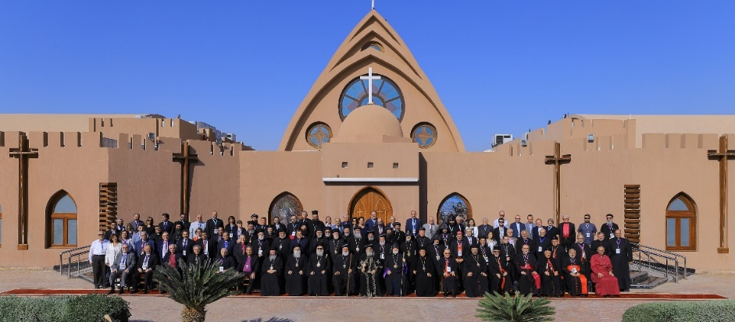

The [Middle East Council of Churches (MECC)](https://www.mecc.org/) is an ecumenical body that embraces the four church families in the Middle East. It pursues towards church unity and enhances ecumenical as well as inter-faith dialogue to advocate about peace, social, and economic justice through the variety of designed activities that achieve the strategic directions of the council.

We at MECC are very thankful to our partners who support our cause and provide the necessary inputs to achieve our goals amid many crises that hit the Middle East region today and especially by supporting MECC humanitarian response in places that are witnessing protracted crises and sectarian conflicts. We are thankful likewise to all our stakeholders including the beneficiaries to make our interventions impactful and to achieve our God’s call to serve all people in need.

We in the Middle East pray for the peace and stability in our region and in the whole world, for the end of wars and conflicts, for all suffering people whether be refugees, displaced or wounded or injured people, for the widows and orphans, for the left children who suffer from all kind of abuses, for the decision makers to be inspired with God’ spirit to rule in justice and dignity. We pray for all people to have the ability to stay in their own land, for the end of all kinds of occupation and modern slavery. We pray our Almighty God to be always in our midst, guide our steps, to forgive our sins and failures for not be good stewards and act in selfishness in all our actions and behavior. We pray for our land to be as our God wish to be, a land that are preserved and protected so that all people can enjoy fairly with its resources. We pray for the season of creation to reckon that all creatures are made by the hand of our God and all have the right to breath fresh air and drink clean water. We pray for peace to prevail in our hearts and souls.

#### We celebrate the following:

* Fifty years of MECC’s existence and its diligent work for ecumenical rapprochement.
* The diversity of our Christian traditions and languages and their enduring presence in the region.
* The diaconal ministry of the churches in a context of protracted wars and migration.
* The youth who despite challenges and setback still desire to gather and worship together.

#### We pray for and long for the following:

* Wars and violence to cease in each and every country in our region, particularly in Gaza and Lebanon.
* Refugees and displaced people, particularly those forcefully removed from their homes by forces of occupation and those terrorized and intimidated.
* Economic justice for all people, as many have dropped under the poverty line in recent years and struggle to make ends meet.
* Environmental protection, as wars and political instability negatively affect the preservation of natural resources, the responsible disposal of waste, and the safeguarding of biodiversity.

#### Prayer

Lord, your promises are trustworthy, and your mercy is everlasting.   
Your prophets announced the coming of the prince of peace.   
Give us ways to experience his peace in our war-torn region.

You promised to comfort your people.   
Embrace all those who are suffering today and speak softly to them.

Mary rejoiced that you brought down rulers from their thrones.   
We pray that unjust rulers be replaced in our world.

Zacharias foresaw that he will enable us to serve you without fear.   
Encourage us to continue our fearless service in our region.

John the Baptist declared the nearing of your kingdom.   
Grant us to experience its justice and righteousness.

As we wait with hope and expectation, meet us in our broken world  
and give us to experience your joy again. Amen.

#### What can we in Canada do to advocate in solidarity with MECC?

* Advocate for the truth because the truth can liberate us as Christians.
* Amplify the voices of oppressed people.
* Be in solidarity with all suffering people in the Middle East and in the whole world.
* Advocate the Canadian government to stand with the rights of oppressed people, refugees and displaced people and to have a free voice and action.
* Advocate the Canadian people and decision makers to promote peace, to stand against wars in all places and not to support any militarily actions that make ordinary people to pay the price.

## Advent 3: Joy

### Global Partner: Council of Churches in Zambia (CCZ)

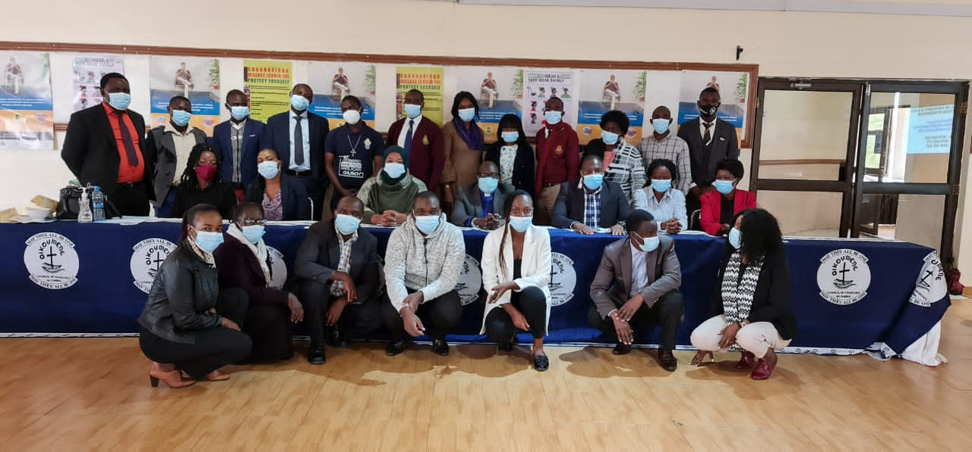

[Council of Churches in Zambia (CCZ)](https://ccz.org.zm/) is an ecumenical church mother body established in 1914.

The vision of CZZ is “to be a prophetic voice with a transformative impact on church and society.”

The mission of CCZ is to strengthen Christian unity and to advocate for social justice, human dignity, good and accountable governance, peace and sustainable development through facilitation, resource mobilization, capacity building, coordination, spreading of the gospel and networking with stakeholders for the benefit of the people of Zambia to the glory of the triune God.

#### We celebrate the following:

* Peace and tranquility; peaceful transitions from one government to another over the last 60 years.
* Contributions to liberations struggles that led to independence of our neighboring countries.
* Abundant natural resources (40% of the water bodies in Southern Africa passes through Zambia).
* Strong cultural and Christian values.
* Vast arable land abundant natural resources.
* Hospitable and generous people.

#### We pray for and long for the following:

* An end to acute poverty in a land of plenty—the abundant natural resources must work for Zambia and its people.
* Praying for sustained peace and unity amidst rising tribal and regional tensions mainly fueled by political players across the political divide.
* Praying for transformational leadership at all levels.
* Economic independence—we need sustainable development that is locally and Zambian driven.
* Prayer against all forms of injustices such as sexual and gender based violence (SGBV), inequalities, and shrinking of democratic, civic, media, and religious spaces.

#### Prayer

Lord God, we adore you because of the joy that advent brings in the context of hope. We are grateful for the blessing of a reconciled life with you and one another. Help us as a people of the Advent joy to bring joy to the hopeless, life to those whom life has lost its taste because of poverty, inequalities, tribalism, sexual and gender based violence (SGBV), violence, and division. Cause us to be disturbed and stand for justice, peace and human dignity. With our hearts filled with joy, we ask all this through the merits of our Lord and Savior Jesus Christ. Amen

#### What can we in Canada do to advocate in solidarity with the Council of Churches in Zambia?

Encourage and advocate for the following through international pressure—contact your MPs!

* Constitutional and institutional reforms
* A level playing field for all political players
* An end to using law enforcement agencies against political opponents
* An end to repeated arrests of political opponents and people with dissenting voices
* An end to multinational mining firms using tax avoidance schemes
* Fighting illicit financial flows and tax evasion
* Protection of good governance, freedom before and after expression, civic and media freedom.
* Resistance to the increasing frequency of closing or restricting freedom of religion and association (a number of churches, namely Catholic and UCZ, have recorded incidents of heavily armed police officers sealing them off to restrict access)
* Ensuring fair trade practices (companies operating in Zambia should adopt fair trade practices that will provide for a win-win situation and a fair share of profits going to locals)
* Collaboration with Zambian NGO’s working to address mining reforms, environmental protection, and community development

## Advent 4: Love

### Global Partner: Ecumenical Bishops Forum (EBF)

The [Ecumenical Bishops Forum (EBF)](https://www.facebook.com/ecumenicalbishops/) is a fellowship of bishops from the various churches in the Philippines united a common desire to serve the Lord Jesus Christ in the particular context of the Philippines. Such services take on a concrete form in providing pastoral guidance to the flock through prophetic ministry.

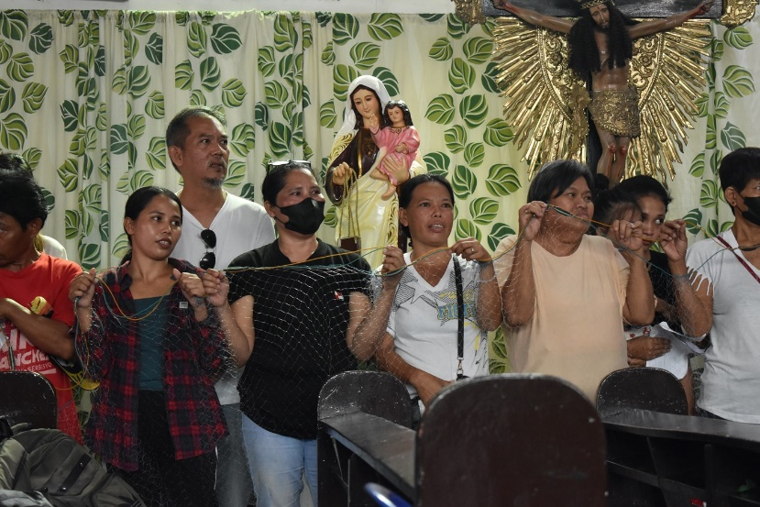

Caption: October 14, 2024, Perez, Bulakan, Bulacan, Philippines. A strong solidarity of fisherfolk and people living along coastal area is a strong testament of unity with the ecumenical churches led by the EBF in raising the struggle against the Aerotropolis (International Airport) project in Bulakan. This event was a symbol of renewed courage and commitment to advance their calls while singing “Pananagutan” or “Accountability” to our “Kapwa”(meaning a brother, sister, or neighbor regardless of status). It is a call to protecting God’s creation, the people and the environment.

Walang sinuman ang nabubuhay para sa sarili lamang. No one is lives alone for his/him/her self.   
Walang sinuman ang namamatay para sa sarili lamang. No one dies alone for his/him/her self.   
Tayong lahat ay may ‘pananagutan’ sa isa’t-isa. All of us are accountable to each other.

#### Our Objectives

* To serve as a forum of the bishops to discuss and reflect on the situations obtaining in their respective episcopal areas and the society at large.
* To provide pastoral guidance to the flock in the form of pastoral letters, statements, and analysis of issues.
* To conduct ecumenical conferences and fora among church leaders to study, reflect, and respond to issues.
* To ensure and advocate policies and programs in the churches that promote peace with justice and abundant life for all (John 10:10*b*).
* Promote and defend the preservation and integrity of creation towards sustainable development.
* Strengthen international and ecumenical solidarity and partnership with churches, NGOs, and Civil Society organizations.

The principal task of the EBF is to organize the Bishops of the Church in order to provide pastoral guidance to the flock as to the current socio-political, economic and cultural issues that confront the Filipino people. This task necessarily includes the following components.

Organizing: This is an internal activity of the EBF where member bishops are consolidated in terms of awareness, understanding and commitment. Organizing also includes membership expansion.

Education: This refers to the conduct or sponsoring of conferences, fora, and such other gatherings where leaders of the churches both lay and clergy are invited as participants.

Documentation and Publication: This refers to the issuance of Pastoral Letters, Public Statements and publication of analysis and reflections.

Sanctuary: Instances where members provide refuge to displaced individuals or groups or are referred to other groups.

#### Target Groups

* For Organizing: bishops of churches. Currently, the bishop-members are the Roman Catholic Church (RCC), Iglesia Filipina Independiente (IFI), The United Church of Christ in the Philippines (UCCP), The United Methodist Church (UMC), Episcopal Church in the Philippines (ECP), Iglesia Evangelica Metodista en las Islas Filipinas (IEMELIF), and Ang Iglesia Metodista ng Pilipinas (AIMP).
* For Education: bishops, vicars, district superintendents, conference ministers, key lay leaders.
* For Documentation and Publications: government agencies, church institutions, church leaders, media, the general public, and the international community.

#### We celebrate the following:

* The gift of opportunity to be of service to others.
* The gift of spirituality, humility, solidarity, and passion for justice and peace
* The gift of steadfastness, love, and resiliency in doing prophetic ministry until the sovereignty of God reigns.
* The gift of time and the opportunity in solidarity with the suffering people.
* The gift of family, friends, churches, and communities in the struggle for peace and justice.
* For the gift of International Community, friends, churches for their unwavering support in the struggle for peace and justice.

#### We pray for and long for the following:

* That a just and enduring peace in the Philippines and elsewhere be achieved.
* That the resumption of peace talks paves the way to the resolution of the basic and fundamental problems of the armed conflict.
* That a final peace agreement between the Government of the Republic of the Philippines and the National Democratic Front of the Philippines on social and economic reforms be finalized and signed.
* That extra-judicial killing ends and that the victims be given indemnification to their loss.
* That the government listen to the cry of the people by creating jobs, implement just wages, and the delivery of services to the poor.
* That respect, love and compassion reign in all humanity and that care for Mother Earth be strengthened and sustained.

#### Prayer

Inclusive and Compassionate God,  
We thank you for your protection, your guidance, and the renewal of life. We are grateful for the gift of serving others, especially those who are destitute, marginalized, and afflicted. Thank you for being a God of Light and Love.

In this moment, we humbly seek your wisdom. As church leaders, despite our busy lives and advancing years, stir our hearts to continue serving the poor, the needy, the oppressed, and the forgotten. Forgive us when we neglect those who need our accompaniment and solidarity.

Remind us always, dear God, of our purpose here on earth, so we may be your instruments in advancing your mission. We lift up to you the fisherfolk, the farmers, the migrant workers, the urban poor, and all who are displaced and dispossessed. We remember the women and children whose lives, dignity and livelihoods are destroyed by inequality and greed; those driven from their homes by large-scale mining; those who face harassment, militarization, and abduction; and all whose human rights are violated.

We, your co-workers in the struggle for justice and peace, offer our lives to you. As Rabindranath Tagore prayed, “Into the haven of justice and peace, let my country awake.” AMEN

#### What can we in Canada do to advocate in solidarity with Ecumenical Bishops Forum?

* Immersion of church leaders, academics, youth leaders and professionals into poor communities to listen to the people’s narratives and stories of struggle and pain for the restoration of human dignity.
* Big churches designate one Sunday in every month to offer its services to one basic sector (e.g., Second Sunday will be a Peasant Sunday aside from being a Youth Sunday. Offerings must be collected also for peasant advocacy program).
* Accompaniment and solidarity to all victims of human rights violations. Fact-finding missions, arraignments of the accused, joining metaphysical activity to support this effort (e.g., protest rally outside the court).
* Dialogue with local government units and provincial governments.
* Sustain connections through liturgical gatherings, small group discussions, church hopping for church leaders, etc.