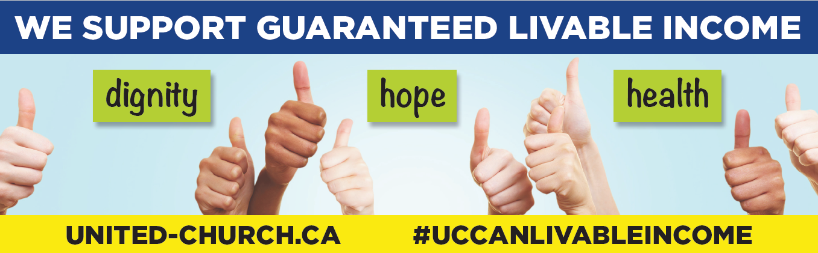
Credit: The United Church of Canada. Photo of hands © Stylephotographs/Dreamstime.com

Guaranteed Livable Income Sunday Guide
October 17, 2021
In conjunction with United Nations International Day
for the Eradication of Poverty

Background
The observance of the United Nations International Day for the Eradication of Poverty can be traced back to October 17, 1987. On that date, more than 100,000 people gathered in Paris, France, to honour the victims of extreme poverty, violence, and hunger. Since that moment, individuals and organizations worldwide have observed October 17 as a day to renew their commitment in collaborating toward eradicating poverty. In December 1992, the UN General Assembly officially declared October 17 the International Day for the Eradication of Poverty (resolution 47/196 of December 22, 1992).
In December 1995, the UN General Assembly proclaimed the First United Nations Decade for the Eradication of Poverty (1997–2006) following the Copenhagen Social Summit. At the Millennium Summit in 2000, world leaders committed themselves to cutting by half the number of people living in extreme poverty by the year 2015.

Guaranteed Livable Income
The United Church of Canada provides a helpful definition of a guaranteed livable income on its website as follows:
A guaranteed livable income (GLI) is a payment to individuals or families by government that covers the cost of basic necessities (food, shelter, clothing, transportation, and community participation) and is not conditional on meeting employment criteria in order to qualify for the benefit. It ensures everyone an income adequate for meeting basic needs, allowing all people to live with dignity regardless of work status. Such a program would be part of the national fabric of services that preserve and protect Canadians; or, as Jesus put it, “to love our neighbours as ourselves.”
Rather than have a rules-based, bureaucratically driven application process (during which applications must prove they are “really poor” before being approved), all Canadian citizens are ensured an automatic top-up when their income collapses for whatever reason. The incomes would be unconditional, automatic, non-withdrawable, individual, and a right of every legal resident.
A guaranteed livable income is an effective way to support the reduction and elimination of poverty and insecurity, the narrowing of extreme income and wealth inequalities, shared citizenship, and improved democratic and economic functioning.
Additional background information can be found on the Guaranteed Livable Income webpage.

Suggested Liturgy and Sunday Program of Action
Morning Worship, Discussion Forum on GLI, and Action and Strategy Planning, including letter writing. Communities of faith may want to consider invitations to worship and discussion following the service. You might consider inviting politicians: municipal, provincial, and federal. During an election period, care needs to be taken to be non-partisan by inviting all candidates in the riding and acknowledging those present and those who declined the invitation. Invitations may also be extended to those in the community known to be living below the poverty line. If this invitation is extended, care needs to be given to circles of dialogue and conversation, storytelling, and experiences.

Worship
*Can be read or can show video of Moderator (youtu.be/5dXOzVDchyo).

*Introduction
On this 29th United Nations International Day for the Eradication of Poverty, we come together as church to call to mind the divine community that God imagines for all God’s people. A community of love, justice, dignity, and full participation. A world without poverty. In Canada, nearly 5 million people live in poverty. One effort toward God’s kin-dom is the call for a guaranteed livable income program. Together may we reflect on the Word and be moved into the world.

*Call to Worship (can be read or can show video of Moderator, youtu.be/5dXOzVDchyo)
We gather together
as grateful people seeking Christ’s Word made new
for this time and this place.
We gather together
to do all we can to live the Creator’s intention
of community of right relations,
of community of peace.
We gather together
ready to act as the Spirit guides us.
With our seeking, our living, our acting,
we worship God.

*Opening Prayer
Let us pray:
Creator God, with gratitude we come seeking
a new word and deed for our time.
May the passion of your Holy Spirit fill us,
that we might live Jesus’ call to be true community―
living right relations and peace on earth.
Amen.
―Right Rev. Richard Bott and Hallett Llewellyn (Rev. Dr.)

Lectionary Readings for October 17
Job 38: 1‒7 or Isaiah 53:4‒12 Psalm 104:1‒9 or Psalm 91:9‒16
Hebrews 5:1‒10 Mark 10:35‒45

Alternative Biblical Readings that relate to GLI theme:
Matthew 20:1‒15 Mark 5:21‒43 Mark 6:30‒46 Micah 4:1‒5 Amos 5:4‒15
Matthew 25:31‒45 1 Corinthians 12:21‒26 Acts 4:32‒35

Hymns and Songs for Justice
- See Songs and Hymns for Sing for Justice, Centre for Christian Studies website.
- From Voices United the following may be considered: 295, 582, 701, 298, 299, 600, 678, 697, 695, 603, 593, 699, 681, 685.
- From More Voices the following may be considered: 1, 6, 12, 78, 80, 112, 114, 117, 127, 145, 154, 162, 171, 191, 193, 209.

Sermons
Several sermons and a theological rationale for GLI effort in the Worship section of the United Church website (International Day for the Eradication of Poverty page) may be used as guides for sermon development, or with acknowledgement used as printed. In the Circles of Dialogue and Discussion section below, items 2 and 3 provide links to videos of basic income advocates who have first-hand experience of poverty and some of basic income. Listening to these stories is an excellent starting point to then reflect on the Word in this context. In place of a sermon, you might consider a dialogue with someone in the community who is knowledgeable on the GLI theme, or with someone who has experience in living below the poverty line and can speak to what difference a guaranteed income would make.

Worship Resources to Use as Aids for Developing Worship for GLI Sunday
- GLI prayers are included in Worship Resources: Guaranteed Livable Income in the Worship section.
- Sample Worship Template for GLI Sunday: A worship service drawing on services and prayers from St. Thomas Wesley and Knox United Churches of Saskatoon, Regina Anti-Poverty Ministry and the United Church GLI network, also in the Worship section.
- A three-part worship video series on the Basic Income theme from St. Thomas United Church and Foothills United Church, Calgary. Full text is available from justice@united-church.ca.
- Hunger for Justice Liturgy is written by Barry Morris, a minister with the Longhouse Council of Native Ministry in Vancouver, BC, for the UN International Day for the Eradication of Poverty.

Circles of Dialogue and Discussion
Here are a few suggestions of ways to engage your community of faith in Circles of Dialogue and Discussion regarding a guaranteed livable income. Be sure to review the materials ahead of time and make sure they are a good fit for your group.
- The Basic Income for Canada video developed by the Basic Income Canada Network describes the meaning and practice of a basic income. It could be used as a basis for discussion on the need for such a program in Canada.
If people who live below the poverty line have been invited, take care with how to hear their story, with sensitivity in preparing questions to be asked. You might consider the following questions:
- What in the video relates to your experience?
- What values are being expressed?
- What would you affirm in the video? What questions remain for you?
- What action possibilities does the video suggest for you?
- Bread & Bricks Davenport West Social Justice Group is a group convened by Davenport Perth Community Ministries in Toronto. Its members have been speaking out for a guaranteed livable income.
Share with the group Olivia de la Cruz’s What would it mean to have a GLI video message and Karlene Cameron’s The Guaranteed Livable Income Is Always a Good Idea blog.
- What expenses and income challenges are people facing?
- What band-aid solutions are not sufficient?
- What difference would a guaranteed livable income make? What difference would it have made if it had already been in place when the pandemic began?
- The Hamilton Vigil for Guaranteed Livable Income was one of 48 vigils held on April 8, 2021. The vigil included testimony from two women who were participants in the recent Ontario Basic Income Pilot, which was prematurely cancelled with the new government in Ontario. Share the testimony of Jodi Dean (20:30) and Alana Baltzer (29:07), who provide first-hand accounts of the difference a basic income program made to them and their families. As well, the Very Rev. Lois Wilson (7:30) provides a good context for the United Church’s involvement, Tom Cooper provides an introduction to the pilot program, and Ted McMeekin (41:40) provides a theological reflection.
Depending on what portion of the vigil you share, you can foster discussion on what happens in the absence of a guaranteed livable income and what difference did/would it make? What new insight did you gain?
For more examples of the difference a guaranteed livable income would make, you may also want to look at Photo Series | Humans of Basic Income.
- Bridges Peterborough is an initiative that bridges poverty and privilege. Its Conversation Changers is a podcast of conversations with people in the Peterborough, ON, area who live below the poverty line. You might consider sharing Episode 2 of Conversation Changers, featuring storyteller Lynn Smith-Reeve. *Language may not be appropriate for all contexts. Use with discretion. This podcast does not directly address livable income but these possible discussion questions can help make connections:
- Discuss the role poverty played in Lynn’s story. How might these events have differed if a guaranteed livable income program had been in place?
- Did this story change your perception of poverty, homelessness, or the state of being under-resourced in any way?
- How has listening to this podcast changed your opinion on the importance of a guaranteed livable income or increased your interest in advocating for one?
- In Lynn’s story, who are all the people who would benefit from a guaranteed livable income?
Additional resources that could be used for discussion can be found on the Create a Guaranteed Livable Income Program webpage.

Action for a Guaranteed Livable Income
Provide an opportunity for your community of faith to communicate support for a guaranteed livable income. A sample e-mail and action ideas can be found on the Create a Guaranteed Livable Income Program webpage.
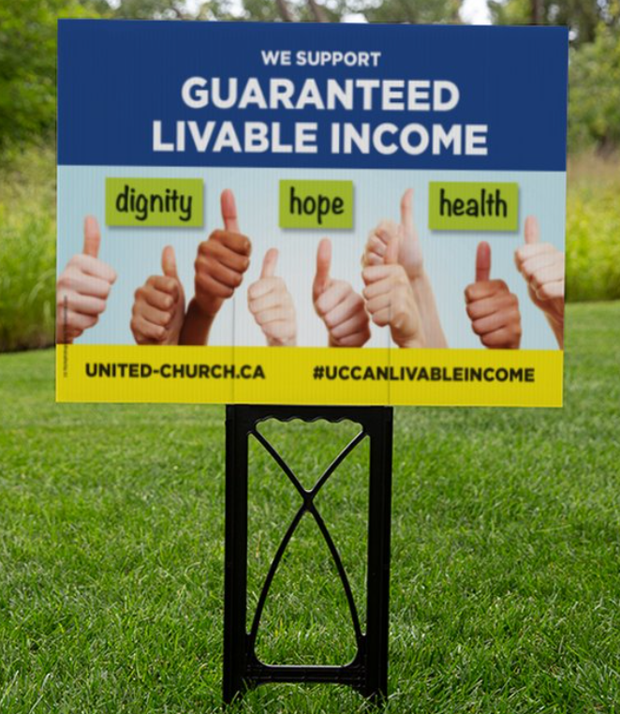
Please e-mail justice@united-church.ca if you have questions or suggestions or wish to sign up for the GLI supporters e-list.
October 17 is also an important day for climate justice as Faiths 4 Climate Justice actions take place on this Sunday, two weeks before the UN COP26 Climate Conference. Both GLI and climate justice are part of a just recovery.

