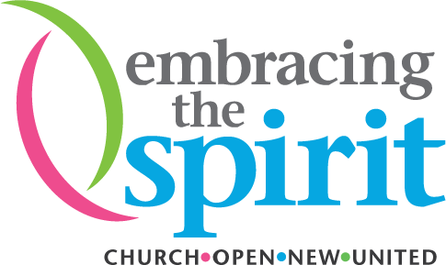
Embracing the Spirit Loan Application

Before You Begin
This form has been designed to be easy to get through and should take less than an hour to complete.
Before sitting down to fill out this form, you should have the following;
- an understanding that only communities of faith within The United Church of Canada network are eligible for a Pay It Forward Loan
- an understanding of the problem and solution that you are proposing
- some thought around the impacts of your proposal based on the quadruple bottom line (financial, social, ecological, and spiritual impacts)
- a clear understanding of how this ties to your existing mission and how this might look in the future
- how much you are asking for
(asterisks indicate which of the questions below must be answered)

About You
Your Name* (both first and last name)

United Church’s Name (Payee)*

Full Mailing Address*

E-mail*

Phone

Overview
Please describe your initiative in 250 words (this is to be used in The United Church of Canada’s communications about your initiative)

URL (Web address or social media to reference in communications)

Identify the Problem
(What is the problem/need/opportunity that you are addressing?)
- What is the problem?

- How important is this problem? How impactful is this problem?

Identify the Solution
(What is your idea?)
- How are you going to solve this?

- What is unique about the idea that you are proposing?

Getting Started
(What do you need to get started? How are you going to get it?)
- What are you asking for from Embracing the Spirit? (Please include your budget here. This should not be a lump sum; it should have a breakdown of the costs in at least three line items.)

- What previous funding have you received to get to this point?

- Why is a Pay It Forward Loan the right financial option at this time?

- What are your revenue streams? How have you validated these revenue streams?

- Who are you going to partner with? What will they bring to the project? (This could be a partnership in place or someone you are just starting conversations with.)

- What else are you planning to do to get started?

- Volunteers? Website? Marketing? Other activities you’ve already started?

What Will Be the Impact?
(How will this make a difference in the neighbourhood?)
- Which of the UN’s Sustainable Development Goals (SDGs) are being impacted by this idea (select all that apply)? Learn about the SDGs.

  - No poverty
  - Zero hunger
  - Good health and well-being
  - Quality education
  - Gender equality
  - Clean water and sanitation
  - Affordable and clean energy
  - Decent work and economic growth
  - Industry, innovation and infrastructure
  - Reduced inequalities
  - Sustainable cities and communities
  - Responsible consumption and production
  - Climate action
  - Life below water
  - Life on land
  - Peace, justice and strong institutions
  - Partnerships for the goals

- Social Impact: Who is this helping and how much is it helping them?*

- Ecological Impact: How does this connect with the environment?*

- Financial Impact: How will this be sustainable? Is it?*

- Spiritual Impact: How does this deepen spirituality or engage in discipleship?*

Your Organization
(Is this a good fit with your organization?)
- What is your theological basis for this initiative?

- Is this a good fit with your current mission? Why?

- How will this initiative impact what the community is saying about your church?

- Where do you see your idea in five years from now? What are you hopeful of in the future?

NOTE*
□ By submitting this form, you agree to abide by the covenants outlined on the Innovation Grants page.

