Celebrations of United Church Women Anniversaries
Celebrations of the United Church Women anniversaries started with the 25th Anniversary in 1987; the 35th Anniversary was celebrated 10 years later in 1997. It was decided to celebrate every 5 years from then on. To celebrate the occasion in 2012, a 50th anniversary project was adopted. It was to support the Morogoro Women’s Training Centre in Tanzania. Over $268,000 was raised to support the training school, and as a result over 600 women were trained in maternity health care. In 2017, the United Church Women celebrated its 55th Anniversary, “Celebrating Spirit”, in Vancouver, British Columbia.
The 60th Anniversary celebration of the United Church Women will be held in Sydney, Nova Scotia, in 2022. The theme is “Continuing in Hope”. The anniversary project Women for Change, Zambia will end in 2022, and a new initiative will be chosen for the next 5 years.
- The 25th Anniversary “Called to Respond” was held in 1987 at the University of Waterloo
- The 35th Anniversary “Rejoice and Risk” was held in 1997 at McMaster University, Hamilton, Ontario
- The 40th Anniversary “Side by Side” was held in 2002 in Winnipeg, Manitoba
- The 45th Anniversary “We Are One” was held in 2007 in Corner Brook, Newfoundland and Labrador
- The 50th Anniversary “Our Tapestry of Love” was held in 2012 in Ancaster, Ontario
- The 55th Anniversary “Celebrating Spirit” was held in 2017 in Vancouver, British Columbia
- The 60th Anniversary “Continuing in Hope” is planned for 2022 in Sydney Nova Scotia

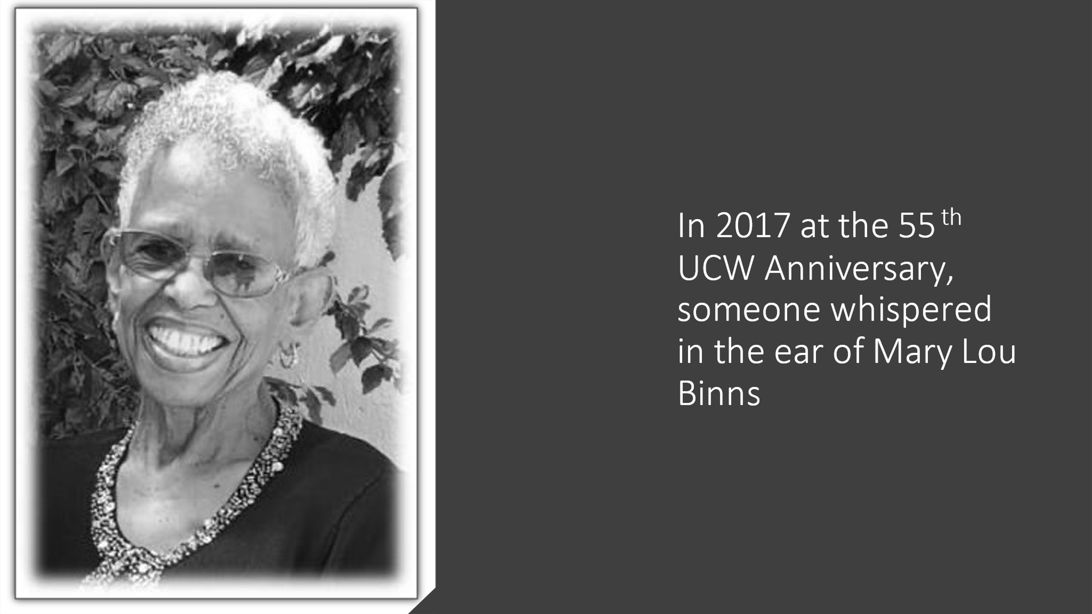

AND THE 60TH THEME WAS BORN
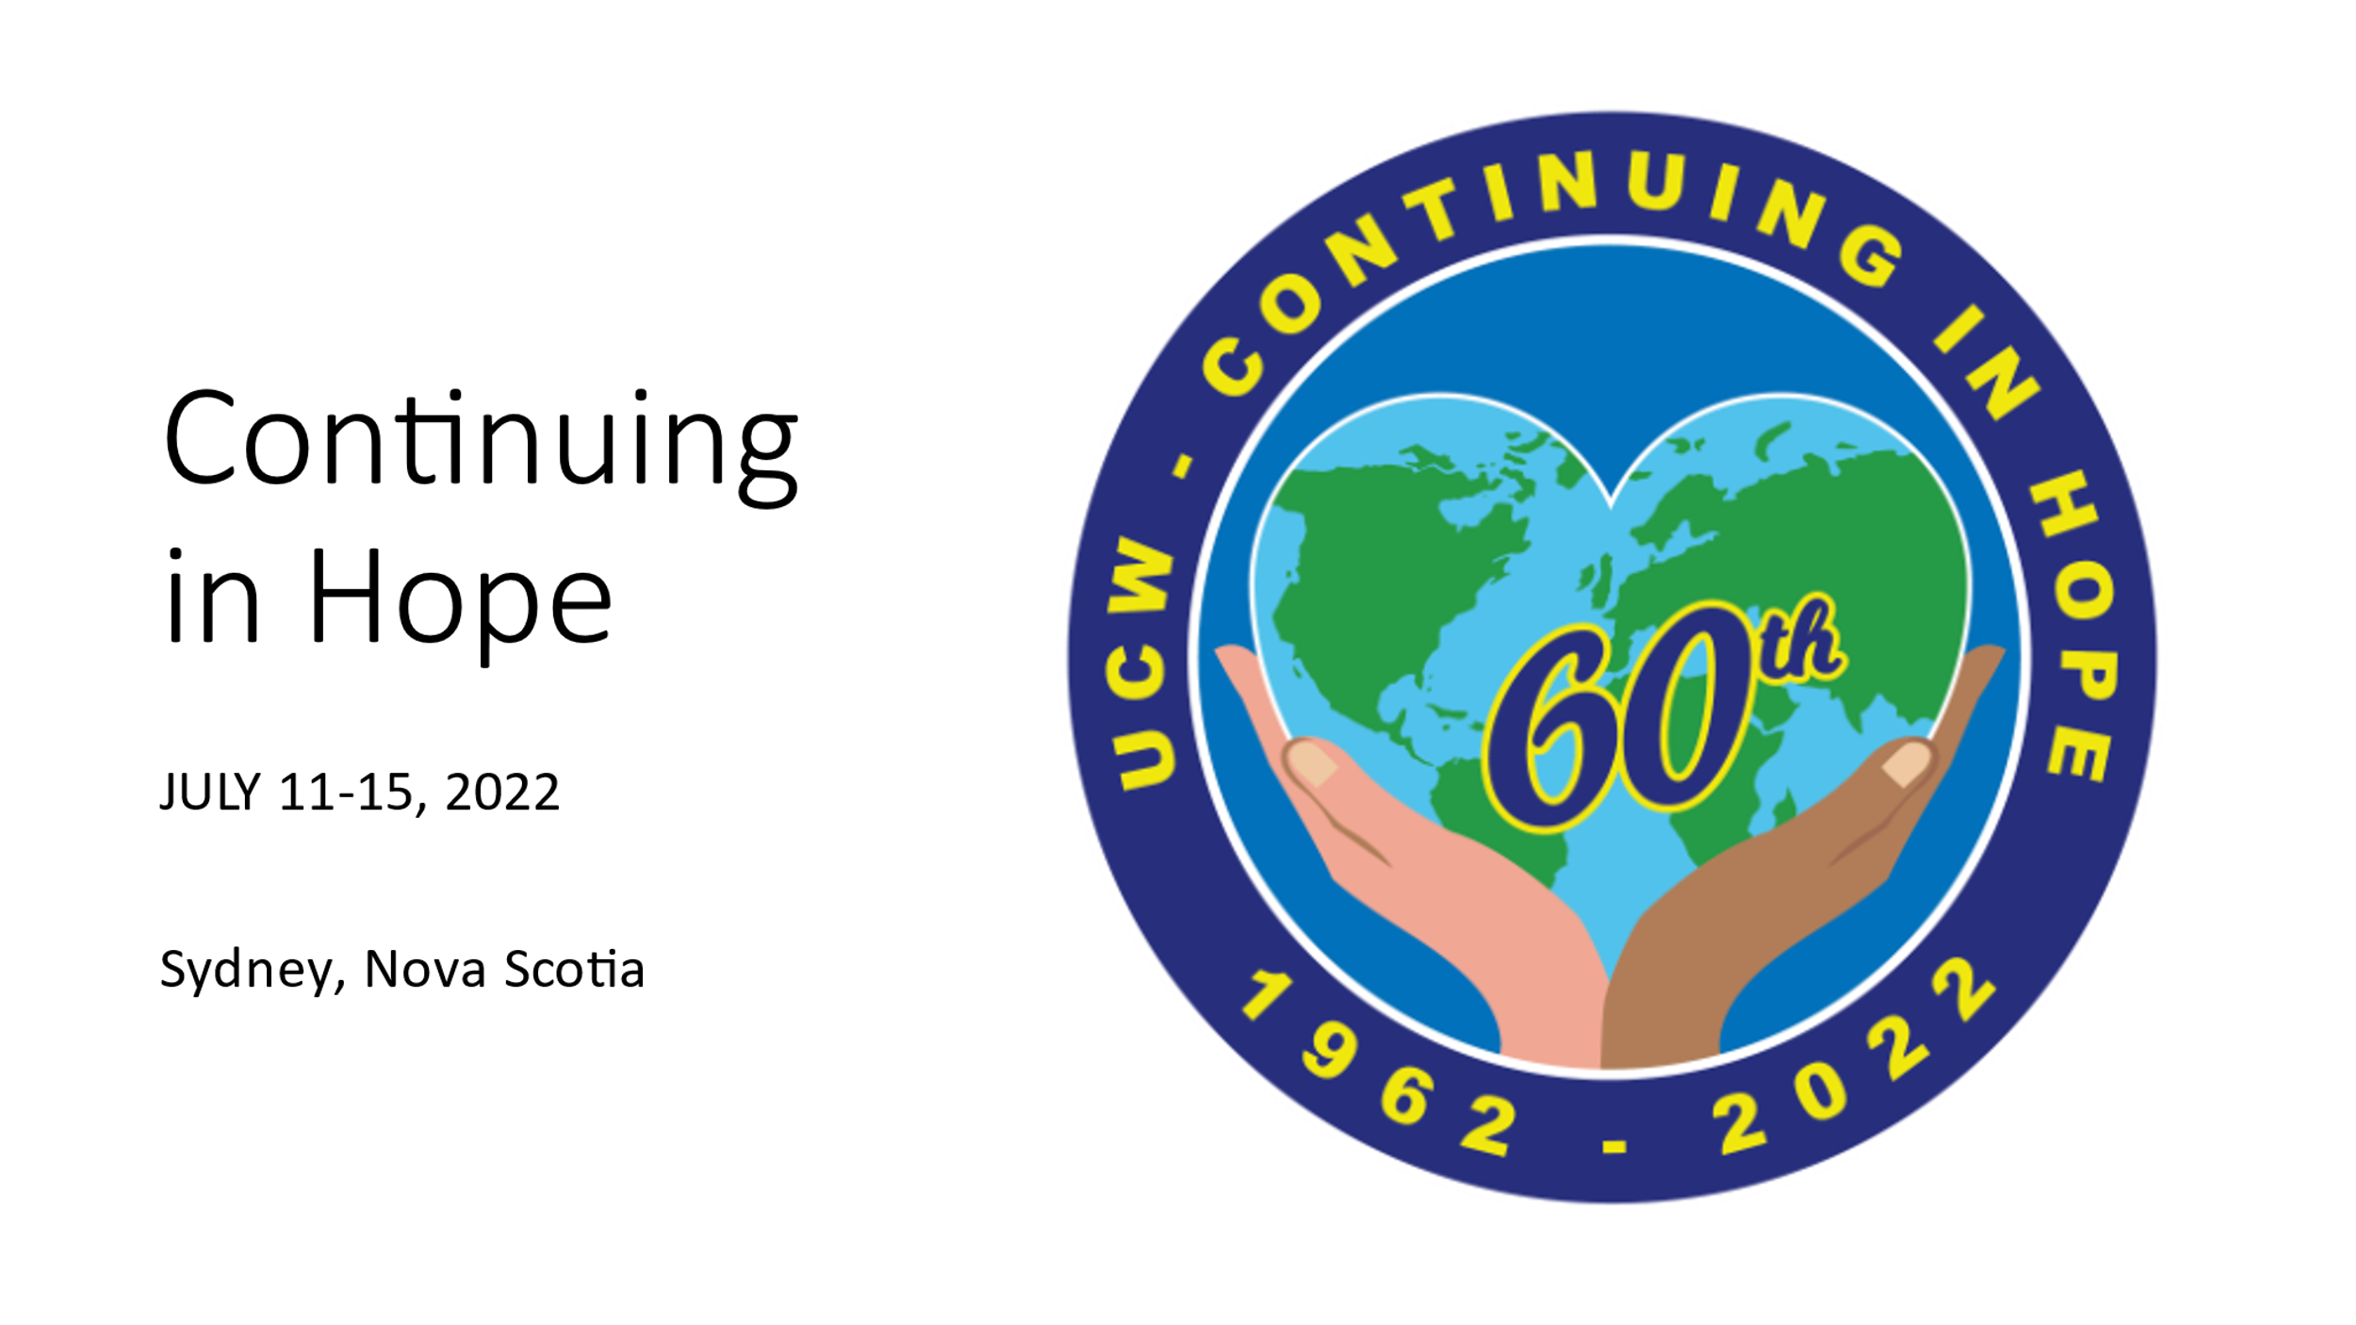
Please link to UCW's 60th Anniversary News (ucceast.ca) for all your information

